Purpose of the GUI

This GUI is for the navigation of a main menu for a game

The menu consists of a:

* New game button & pop-up for it.
* Continue button.
* Load button & menu change.
* Options button & pop-up for it.
* Quit button.

Itemise UI events

Flow Chart

[GUI Design By Richard-Flowcharts.drawio.png](GUI%20Design%20By%20Richard-Flowcharts.drawio.png)

What tools & programming language will the GUI be built in

Unity Canvas, C#, & Unity’s new input system.

Screenshot/Mock ups of GUI, Illustrations/examples of animation being used

Main Menu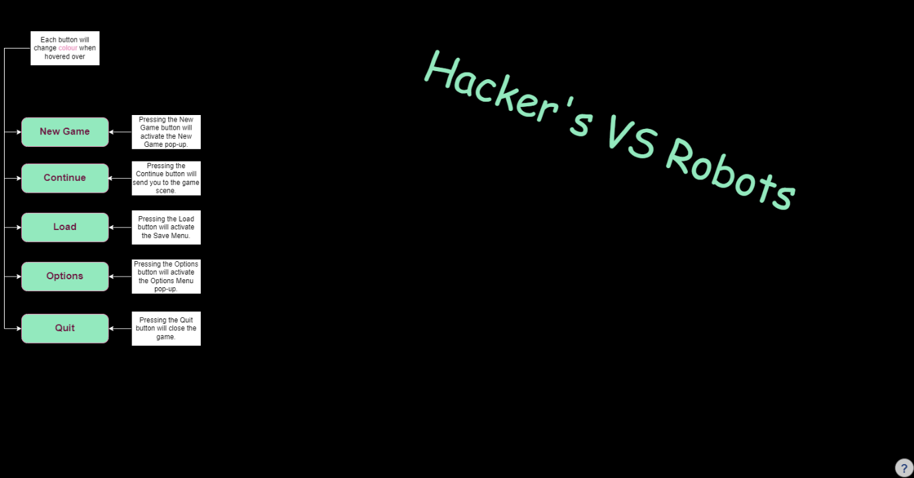[GUI Design By Richard-Main.drawio.png](GUI%20Design%20By%20Richard-Main.drawio.png)

New Game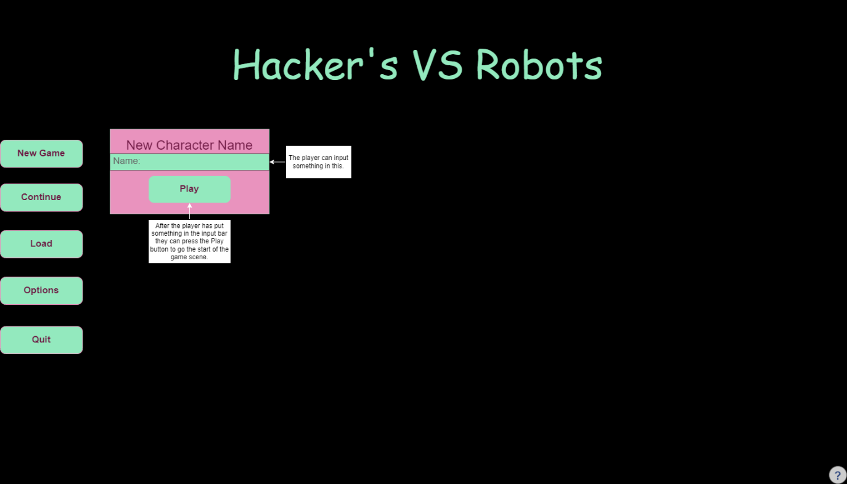[GUI Design By Richard-New Game.drawio.png](GUI%20Design%20By%20Richard-New%20Game.drawio.png)

[GUI Design By Richard-Save Menu.drawio.png](GUI%20Design%20By%20Richard-Save%20Menu.drawio.png)

[GUI Design By Richard-Options Menu.drawio.png](GUI%20Design%20By%20Richard-Options%20Menu.drawio.png)

OOP (object orientated programming) concepts used in GUI

Encapsulation is being used for grouping things together.

Here are the planed encapsulations:

* Main Menu Buttons
* New Game pop-up
* Load (Save) menu
* Options Menu

Abstraction

Inheritance is being used

Polymorphism: Having classes behave differently when using the same function

API features used in building GUI

What open-source development tools could be used developing a GUI

Potential Legal issues concerning intellectual property, privacy & data